D1_Nihar_84066
ASSIGNMENT 4
1. D1_nihar_84066>select Onum, Amt, Odate from ORDERS;
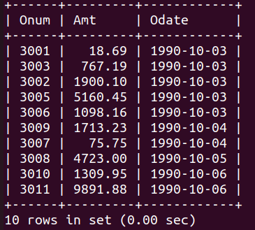

2.D1_nihar_84066>select * from CUSTOMERS where Snum=1001;
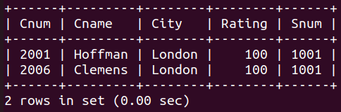

3.D1_nihar_84066>select City, Sname, Snum, Comm from SALESPEOPLE;
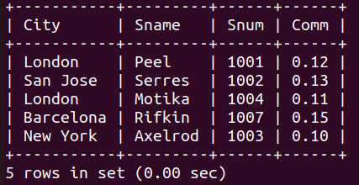

D1_nihar_84066>select Rating, Cname from CUSTOMERS where City ='San Jose';
